

**B.Tech(CSE) Semester – III**

**Summer Internship (Online work)**

Phase-2 Report

Name: SWEKIT PATEL

Roll No: 22BCE347

Division: F-1

**Organization details**

• **Name of the Organisation**: Hamari Pahchan NGO

• **Name of the contact person**: Anjali Mathur (President), Ms Tanya (Internship Coordinator)

• **Address:** H. No. 1121, Mahipalpur Bypass Road, opposite Arjun Camp, New Delhi 110037

• **Telephone:** 9911173557, 7800043888

• **Email:** [pahchanhamari@gmail.com](mailto:pahchanhamari@gmail.com)

• **Website:** www.hamaripahchan.org

• **Major activities:**

1. Designing content for social media
2. Crowdfunding
3. Working on an individual project regarding a survey
4. Digital media marketing
5. Creating the poster

• **Time duration**: 22/07/2023 - 28/07/2023 (12 to 13 hours of work)

• **Location of activities**: Online activities

**About the Hamari Pahchan NGO**

How It All Began

“Don’t go out in the dark, it’s not safe,” said Tarun Mathur to his daughter Meharr Mathur after the Nirbhaya incident had jolted the entire nation.

At that moment Meharr said something which would

stir difficult feelings for Mr. Mathur, she said, “Don’t stop me, make Delhi safe!”

Hence, established in the aftermath of the horrendous Nirbhaya incident in the year 2015, its founder Mr. Tarun Mathur shaped the organization in order to make Delhi a safer place to live and thrive in.

For the past seven years, Hamari Pahchan, as a non-profit organization, has devoted itself to people in need.

With multiple initiatives spanning a variety of causes

Hamari Pahchan aims to eliminate social evils like

hunger, illiteracy, and period poverty, and strives to promote causes like menstrual hygiene, elderly well-being, and many more.

Our Vision

To help everyone create their own identity, hence, Hamari ‘Pahchan’ (Our Identity.)

#### Our Mission

We seek a world full of hope, tolerance, and equity, where there is no poverty and everyone lives with a sense of dignity and security.

#### Our Values

We believe in integrity, transparency, equity & and justice.

**Activity 1: Introduction and Fundraising**

Day 1 (22 July 2023)

* On day 1, we were introduced to the NGO's mission and all the work it dedicated to the betterment of society through an online Zoom meeting.
* I had an amazing interaction with the internship coordinator Ms. Tanya.
* After the meeting, we were assigned our first task.

Task 1: I was asked to choose from various topics on social work and I picked Education for all. I was supposed to create an online fundraising page on milaap.org.

Task 2: Share the fundraising link to more than 50 people via WhatsApp broadcast.

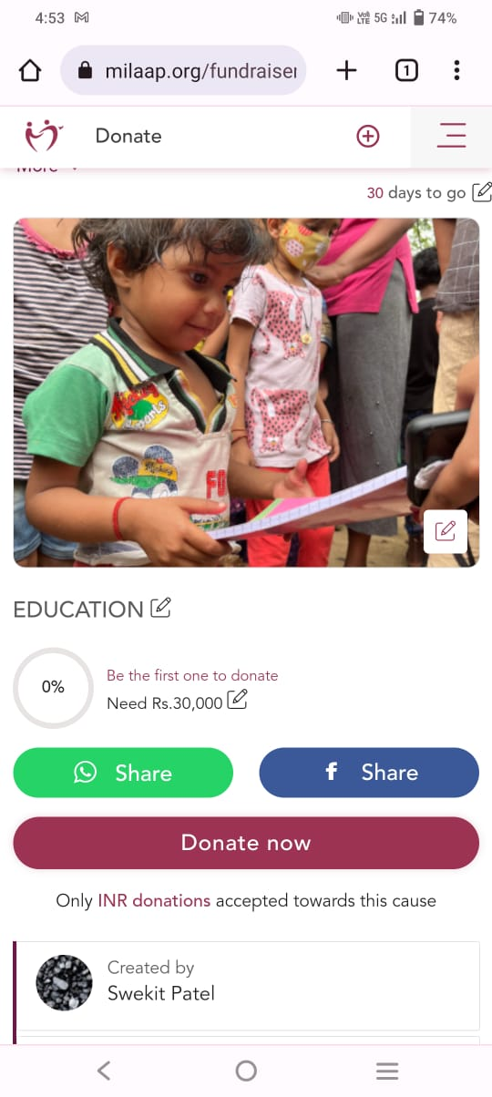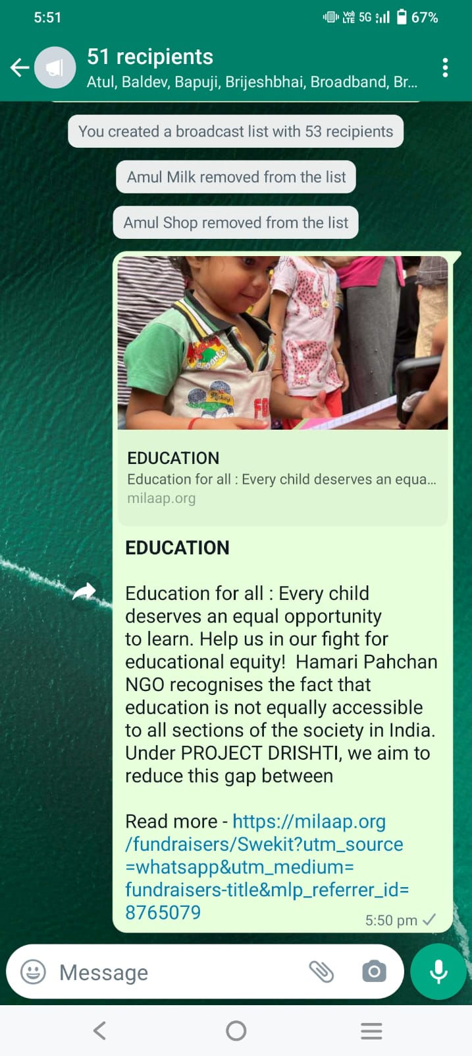

**Activity 2: Sharing fundraising link & Self-introduction**

Day 2 (23 July 2023)

* On day 2, we were assigned two tasks.

Task 1: Share a fundraising link on Instagram

Task 2: An introductory essay about ourselves in a pdf format.

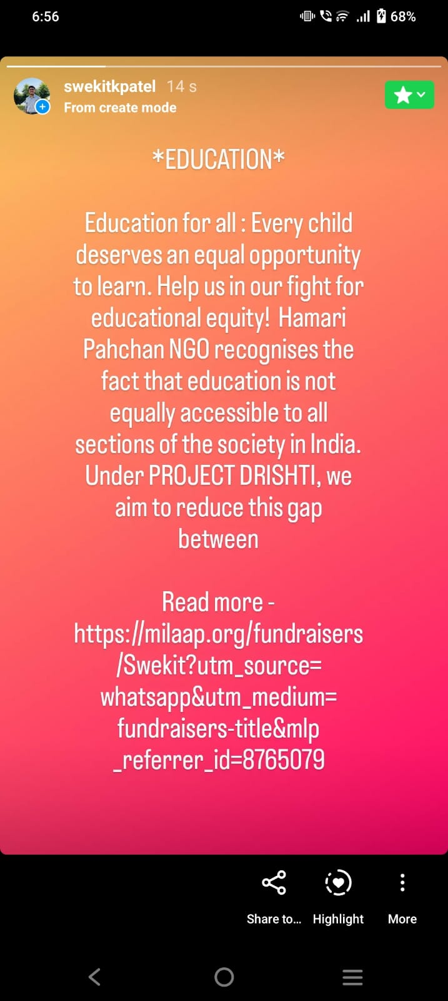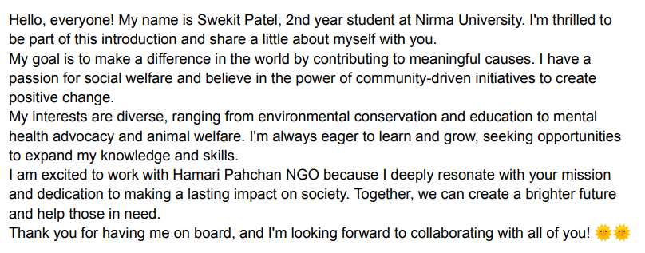

**Activity 3: Blog Writing**

Day 3 (24 July 2023)

* On day 4, our task was to create a blog on the “Education for All” topic. I was asked to do research on the topic and write a blog in Hindi or English on the Youth ki Awaz platform.
* My article link: https://www.youthkiawaaz.com/2023/07/education-for-all-41

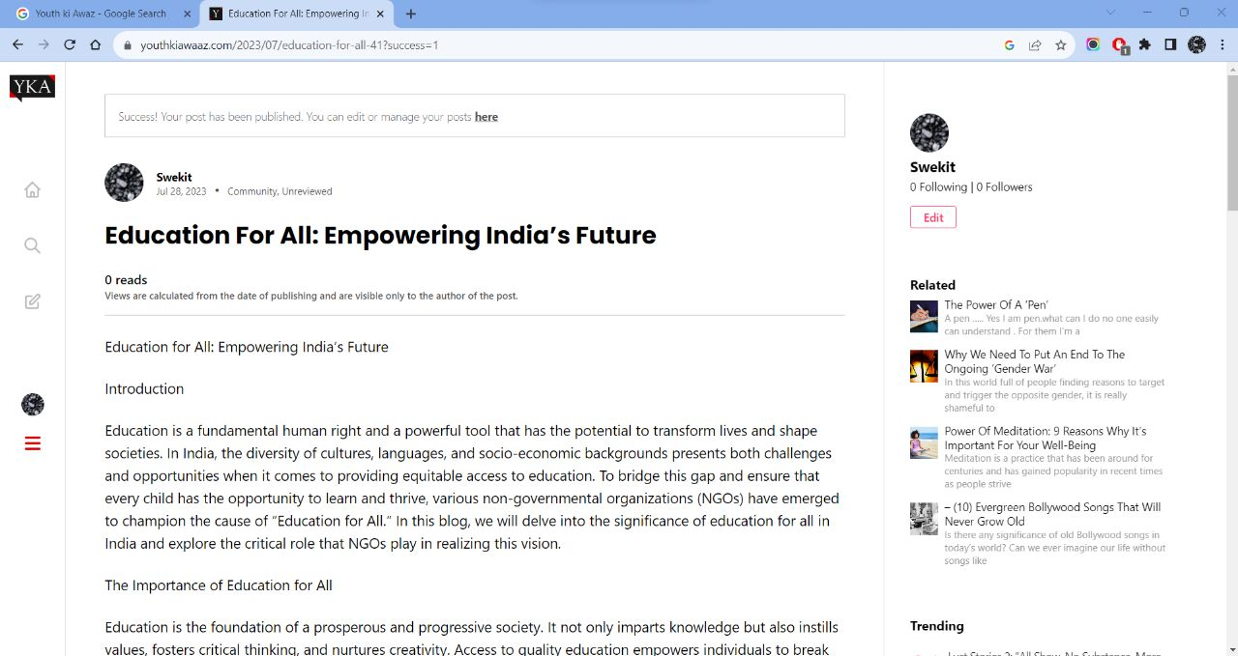

**Activity 4: Survey**

Day 4 (25 July 2023)

* On day 5, I was asked to explain to my friends about the Hamari Pahchan NGO.
* There was a Google form that I created to survey if anyone would like to join the NGO and their views about societal work.
* There were around 10 responses to the Google forms where they shared their contact details are wanted to work in the NGO.

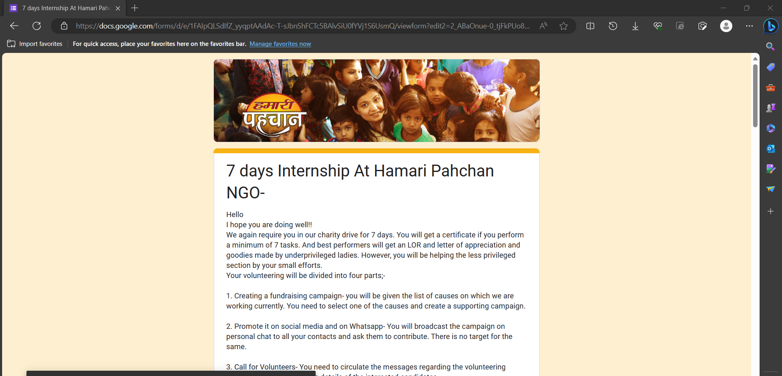

**Activities 5: Poster Making**

Day 5 (26 July 2023)

* On day 5, I was asked to prepare a poster on the topic “Education for All”.
* This activity was aimed to spread awareness among people and work together to provide free and quality education via online platforms as well as through schools.

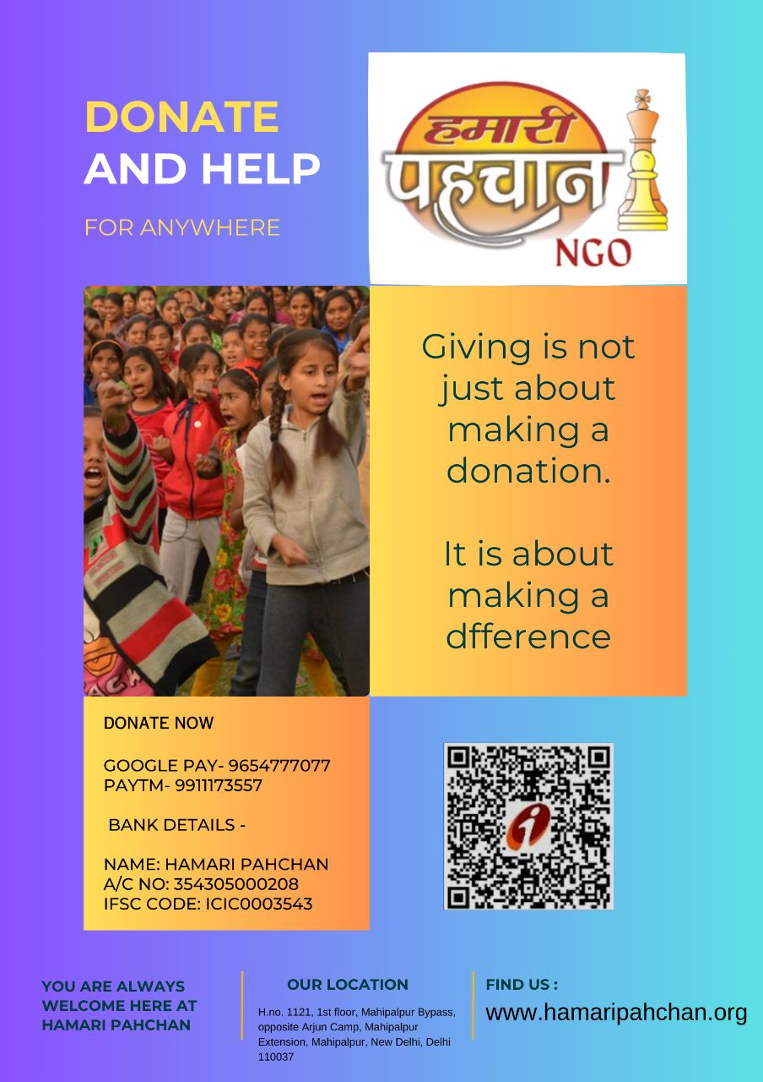

Photo: My Post

**Activity 6: Interaction with special guest speaker**

Day 6 (27 July 2023)

* On Day 6, I was an attendee at a special webinar from Ms. Meghna Sehra.
* She has 9 years of experience in criminal, civil, and matrimonial. Cases and is a member of the High Court Bar Association
* Her lecture on Legal Aid helped me learn new things.
* The lecture also included many other topics like providing funds to help NGOs.

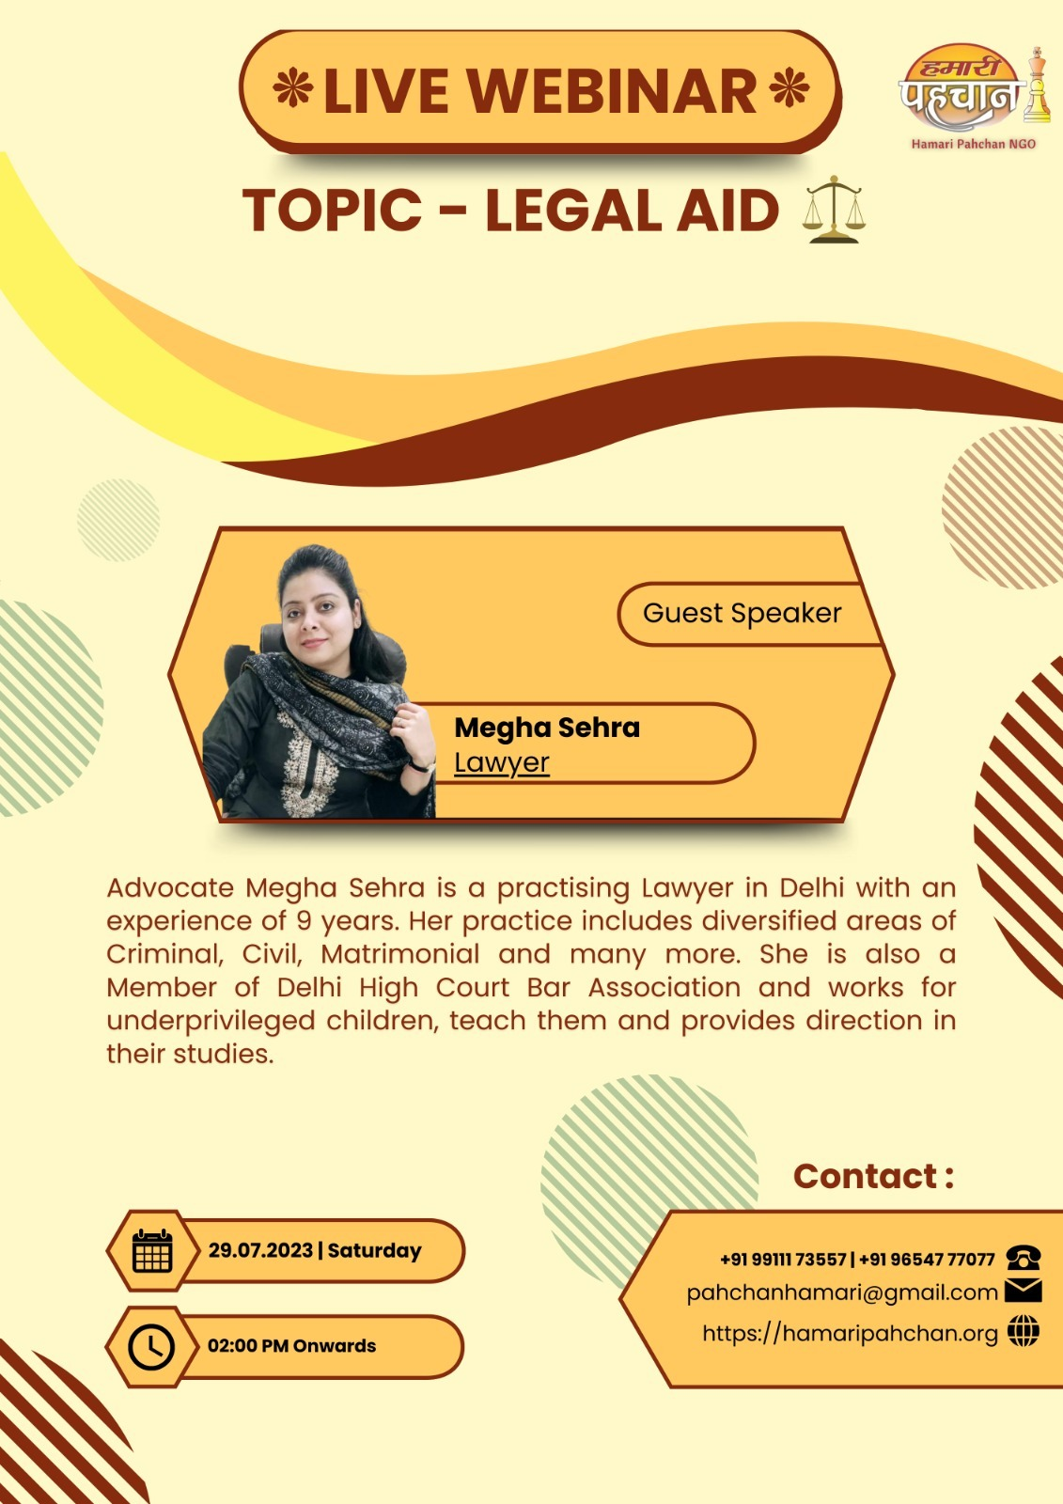

**Activity 7: Instagram content making, Fundraising**

Day 7 (28 July 2023)

* On the last day, I was asked to make a reel for their Instagram account on the topic “Education for all.”
* The next task was sharing the fundraising reel on WhatsApp status.
* The next task was to follow them on LinkedIn.

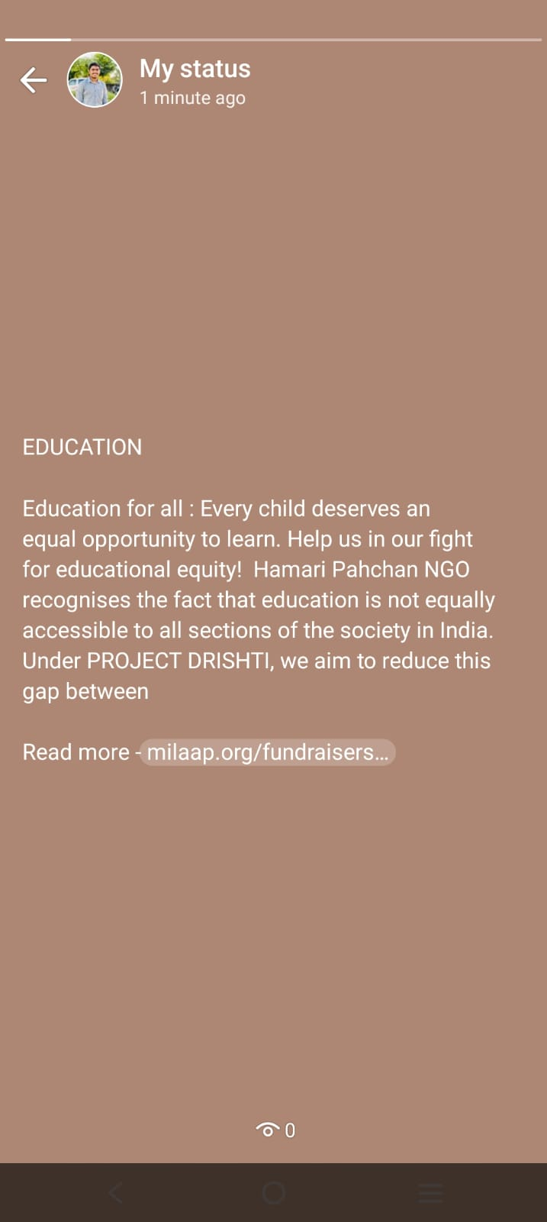 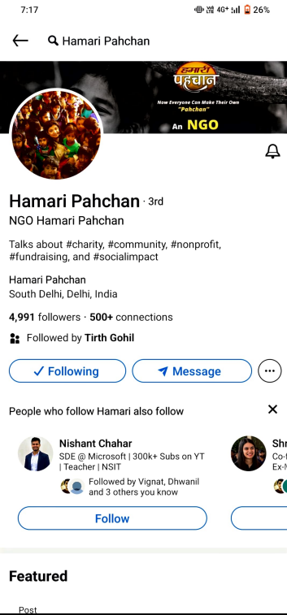

**Certificate**

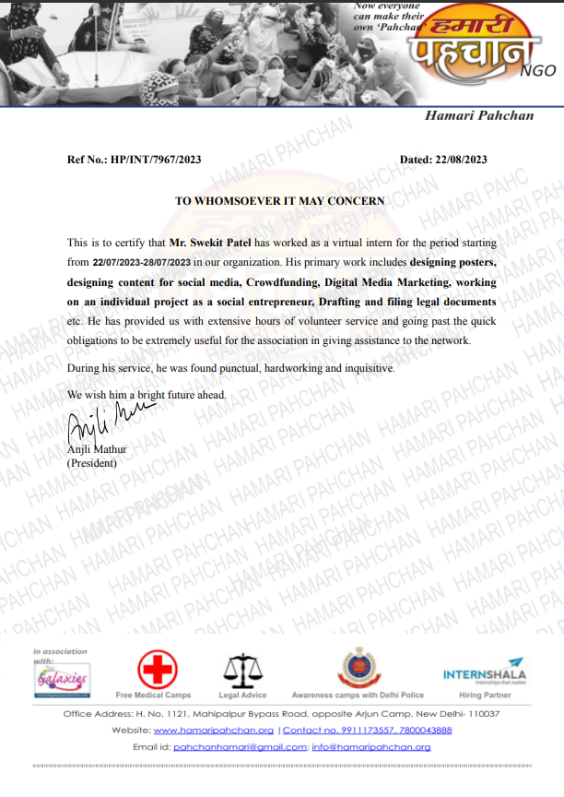

**Beneficiaries of Activity from Community/City/Village**: People associated with Hamari Pahchan through online or offline medium

**Identification of the problems associated with the concerned community/NGO:**

There were several problems associated with the community:

* In the era of digitalisation everyone now is using phones.
* But reaching backward-class communities is a difficult job.
* NGOs like Hamari Pahchan and other similar NGOs are reaching these communities which will be beneficial in the long run as help and knowledge will reach each and every part of the country.

**Technical Solution proposed:**

Develop a mobile health application that offers free virtual consultations, medicine delivery, and health education. This solution leverages smartphones to bridge the gap between impoverished communities and medical professionals, providing essential healthcare services and information, and ultimately improving health outcomes for the underserved.

**Impact of Activity for Societal Benefit:**

During my online internship, I participated in educational webinars for underserved communities, ran a fundraising campaign, volunteered for nonprofits remotely, and worked in online workshops. These activities collectively contributed to improved skills, increased environmental consciousness, enhanced nonprofit outreach, and better mental well-being. Through virtual platforms, I learned to harness technology for broader societal benefits.

**Concluding Remarks:**

Our NGO's dedicated efforts continue to drive positive change. With unwavering commitment, we stride forward, empowered by the impact we've achieved and inspired by the challenges that lie ahead. Together, we shape a brighter future for all.